1. To use the ribbon commands, what menu and grouping of commands will you

find the Insert and Delete command?

Ans

Following are the tabs in the **excel ribbon**. Home: This is the most popular bar and displayed by default when excel is opened. This tab contains the basic Clipboard commands, formatting commands, style commands, commands to insert and delete rows or columns, plus an assortment of worksheet editing commands.

Insert: This tab provides options to insert something in a worksheet- a table, a diagram, a chart, a symbol, Pivot table and so on.

2. If you set a row height or column width to 0 (zero), what happens to the row and

column?

Ans

* Columns: The value or number of the column width is the number of characters that can be displayed in a cell. Excel will default the width to 8 characters (it's actually 8.11). You can set the column width from 0 to 255. If you set the width to 0 (zero), Excel hides the column.
* Rows: The default height is 12.8. The number is a measurement in points - 1 point is about 1/72 of an inch tall. This makes the default height about 1/6 of an inch. Again, just like columns, if you set the row height to 0 (zero), Excel will hide the row.

With the rules out of the way, we can move on to adjusting the height and width values.

**Column Width**

Probably the most common reason for adjusting the column width is for the **header row**, which is a row of column titles. The titles are displayed across the top of the spreadsheet, identifying the subject or content of the column. For example, if we were to create a spreadsheet detailing a list of customers to receive a discount coupon both by mail and email, we would likely need the following five columns:

* Customer Name
* Customer Email
* Customer Mailing Address
* Email Sent (Y/N)
* Mail (postal) Sent (Y/N)

3. Is there a need to change the height and width in a cell? Why?

Ans

It is necessary to change width and height in excel **to fit the data**. Excel by default provide equal width and height with respect to columns and rows. Whenever we enter a lengthy data, few characters will get displayed and other will be present inside the cell but will be hidden to the user.

4. What is the keyboard shortcut to unhide rows?

Ans

**Unhide Rows Using a Keyboard Shortcut**

1. To unhide all rows, click and drag with the mouse to highlight rows 1 to 7.
2. Press and hold down the Ctrl and the Shift keys on the keyboard.
3. Press and release the number 9 key without releasing the Ctrl and Shift keys. The hidden row(s) will become visible.
4. How to hide rows containing blank cells?

Ans

With the **Go To Special** function, you can select the blank cells first and then apply the short cut keys to hide the rows which contain blank cells. Please do with following steps:

**1**. Select the data range which contains the blank cells you want to hide.

**2**. Then click**Home** >**Find & Select** > **Go To Special**, see screenshot:

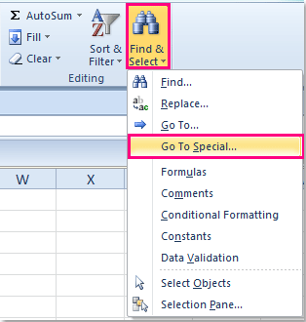

**Tip**: You also can press**Ctrl + G** to open**Go To** dialog and click **Special** to get the **Go To Special** dialog.

**3**. And in the **Go To Special** dialog, select **Blanks** option, and then click **OK** button.

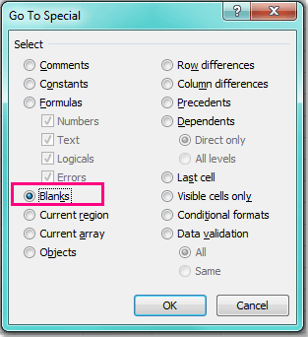

**4**. All of the blank cells in the selection have been selected, see screenshot:

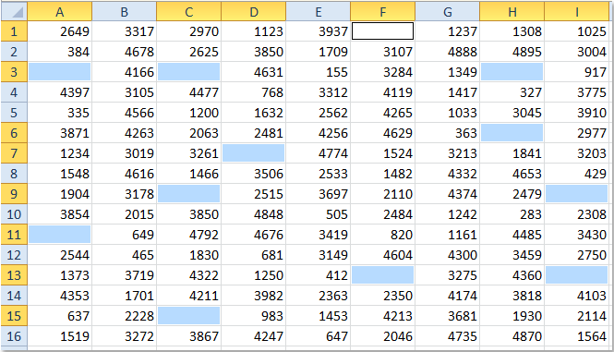

**5**. Then you can press **Ctrl + 9** keys together to hide the rows which have blank cells.

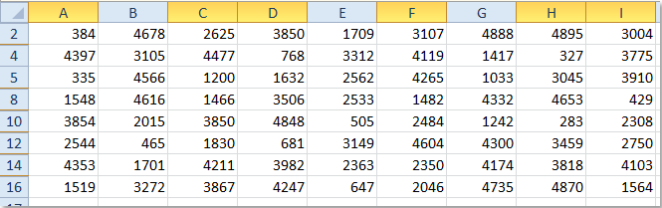

6. What are the steps to hide the duplicate values using conditional formatting in

excel?

Ans

**Hide Duplicate Values**

1. Select range A2:A5.
2. On the Ribbon's Home tab, click the Conditional Formatting button, then click New Rule.
3. Click Use a Formula to Determine Which Cells to Format.
4. For the formula, enter. =A2=A1.
5. Click the Format button.
6. Select a font colour to match the cell colour.
7. Click OK, click OK.